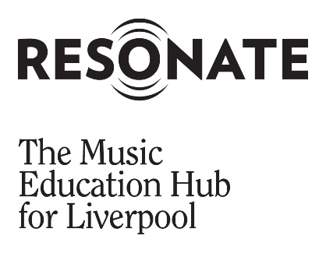
Resonate Board Member Advert
November 2022

Our Vision: Making Great Music. Making Music Great.

Our Mission: Resonate works to enable and equip all our young people with the skills, the opportunities and the resources to make music. We put young people at the heart of everything we do and we are determined to ensure that every young person grows up being able to play, listen to, and create the music they choose to.

Our Reach: Our reach 112,400 pupils, 277 schools, 3 local authority areas, Liverpool, Warrington and Halton.

Your Help: We are looking for an enthusiastic and skilled person(s) to join our board. The ideal candidate(s) will be passionate about music education and can demonstrate this through their professional work or volunteer experience.
About Us
Resonate is led by Notre Dame Catholic College, a successful secondary school in the heart of the city, which is uniquely placed in leading Liverpool’s music education hub.
Resonate is funded by schools and the Arts Council England (ACE), and functions as a gateway for Liverpool’s young musicians. In the last three years over 40,000 pupils in Liverpool had access to outstanding music opportunities which will impact their lives and enhance our city.

Working with partners from across Liverpool, including Royal Liverpool Philharmonic, Liverpool City Council, Culture Liverpool and Liverpool’s Family of Schools, we are hugely excited about the future of music education in our region.

Over the last year Resonate has developed a new collaboration with Accent MEH focused on the delivery of music lessons in Warrington and Halton schools. This new step extends our reach to 277 schools across three Local Authority areas.

About the Role
We are seeking expressions of interest from individuals who share our values and passion for music education and are committed to improving opportunities for young people to create music together and progress their musical interests and talents.

The Board consists of professional people across various disciplines which the members seek constantly to broaden, strengthen, and renew.

There are usually four Board meetings per year, these take place in Notre Dame Catholic College and last for around 2 hours. There is an expectation that Board members set time aside to read relevant papers and documentation.

We welcome applications from all sections of our community and, in particular, those with experience in the following areas:

- Fundraising
- Human Resources
- Company Law
- Charity Law
- Marketing and Communications
- Legal Expertise

Term: 4 Years, voluntary

About You
You will contribute to the development of a high-quality, inclusive music education offer, and the steer of strategic development, which will positively impact the lives of children and young people across Liverpool, Warrington and Halton.
Whether you have board level experience or want to make your first step into strategic governance, we want to hear from you. We welcome applications for this voluntary Board Member role from anyone over the age of 18 from all sectors and backgrounds. We especially welcome and encourage applications from people with backgrounds currently underrepresented on our Board, particularly those from our ethnically diverse population, people from the LGBTQ+ community, or people who are disabled.
Next Steps
If you are willing to commit your time and expertise to help us build an inclusive music education offer, across Liverpool, Warrington and Halton we would welcome an expression of interest from you.
Please read through the Terms of Reference and Strategic Role document and complete the Resonate Board Membership Application Form and forward to Jonathan Dickson, Head of Service.

Closing Date:
3rd March 2023

