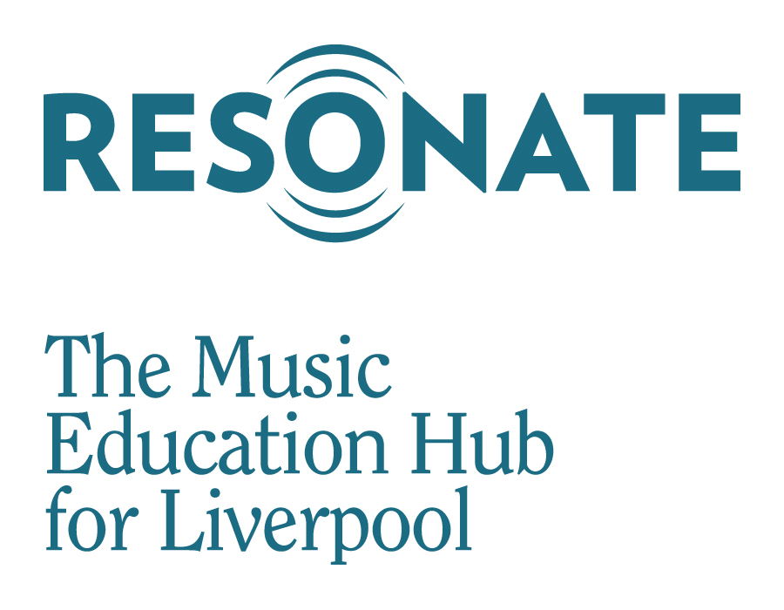

Resonate Music Studios
Financial Assistance Policy 2023/2024

We want your child to play in a band or sing in a choir, we believe this will have a long-term effect on not just their musical skills but also their social skills and skills for life.

Resonate is committed to ensuring that opportunities to play in a band are accessible and affordable to all Liverpool’s young people which is why we have placed so much investment in Resonate Music Studios.

In order to sustain ensemble activity for Liverpool’s young people we ask parents to support us in contributing to the cost of this provision. Whilst we do our very best to keep the costs to a minimum it is worth noting that provision is subsidised so the contribution from parents is critical in ensuring we are able to sustain this activity into the future.

Membership fees only apply to students attending Youth/Advancing Ensembles. RMS Membership to our beginner ensembles such as Let’s Play and Superstarters is entirely free, funded through our Arts Council grant.

Membership 2023/2024

Level 1 Membership fully subsidised, no cost to pupils. This includes all Super Starters activities, Let’s Play and Resonate Singers.
Level 2 Membership £3 per week, £81 per year – Advancing Ensembles including, Resonate Rock, Resonate Brass, Resonate Folk.
Level 3 Membership £5 per week, £135 per year – Resonate Youth Philharmonic available at Notre Dame and Bellerive sites.

Terms of reference
- RMS membership is open to any young person who lives in the City of Liverpool or attends a school in Liverpool up to the age of 18.
- An annual membership charge is made to the parents/carers of children who are members of Advancing Ensembles.
- RMS membership entitles your child to attend as many ensembles as they wish subject to availability.
- A ‘Family Membership’ is available for siblings. The youngest family member will receive a 50% reduction on membership fees.

How do I pay?
- Payment will be made via the Resonate website by registering an account.
- Membership fees are payable before the start of the first session attended.
- Should you wish to withdraw your child from membership of RMS please email: resonatehub.notredame.liverpool.sch.uk
- Unfortunately, we are unable to refund membership fees unless sessions are cancelled by Resonate

Financial Support
We do our very best to make RMS accessible for any young person who has a passion for music and we are aware that for some finding the money to support your child can be difficult.

We offer a limited number of scholarships for cases of financial hardship ranging from a scholarship that offers 100% of the membership fees to a scholarship that offer 50% of the fee.

The provision of funded scholarships is subject to continued funding from Arts Council England. It should also be noted that Resonate reserves the right to limit the availability of scholarships subject to budgetary provision.

100% RMS Scholarship
- All children and young people who reside in Liverpool or attend a Liverpool school and is a Looked After Child can access the 100% RMS Scholarship.
- Children and young people who reside in Liverpool or attend a Liverpool school are currently in receipt of free school meals may also access the 100% RMS Scholarship.
- Evidence of eligibility will be required in order to access this fund.

50% RMS Scholarship
- 50% RMS Scholarships are available for young people who attend a Liverpool school or reside in Liverpool.
- In order to qualify for a 50% RMS Scholarship families must be in receipt of one of the following:

-Income Support
-Income-based Jobseeker’s Allowance
-Income-related Employment and Support Allowance
-Support under Part VI of the Immigration and Asylum Act 1999
-The guaranteed element of State Pension Credit
-Child Tax Credit (provided you are not entitled to Working Tax Credit and have an annual gross income of no more than £16,190)
-Working Tax Credit
-Universal Credit

This means that based on RMS Membership fees 2023/2024 you will pay just £13.50 per term (£40.50 per year) for Level 2 Membership, or £22.50 per term (£67.50 per year) for Level 3 Membership.

Applications for Scholarships
The process for accessing an RMS Scholarship is via a confidential application form. You will be asked to provide evidence to support your application in the form of a letter from your school confirming your child is eligible for free school meals, and or photocopies of letters confirming any allowances you receive.
- Applications for RMS Scholarships can be made at any time throughout the year.
- Applications forms for scholarships are available on our website or upon request.
- We aim to respond to applications for scholarships within four weeks.

How do I contact Resonate?
For further details please contact Mr S Curtis, Head of Ensembles on:

0151 330 5130
resonatehub@notredame.liverpool.sch.uk

